Aussie Kidz Charity Website.

Included Documentation

- Cross Browser Testing.

- Description on how used images chosen meet clients brief.

- Description on how images suit the Web Medium.

- Rational used for Image file format

- Sources and Licences for all images

- Pitch to Client

- Print final design to a single page PDF

- W3C Validation testing

**Cross Browser Testing**

Google Chrome

~~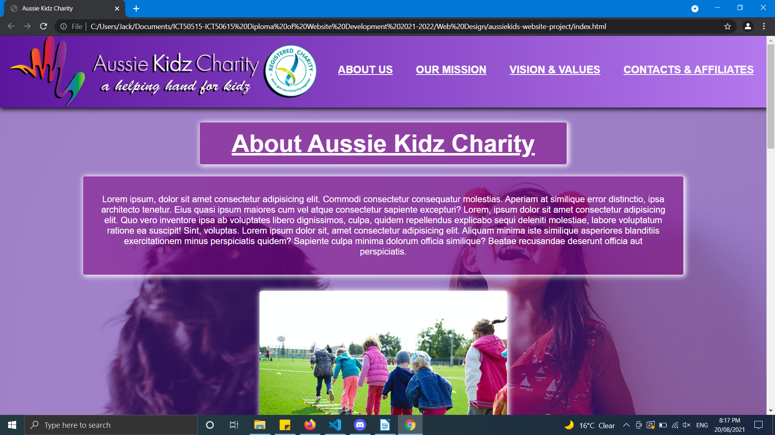~~

~~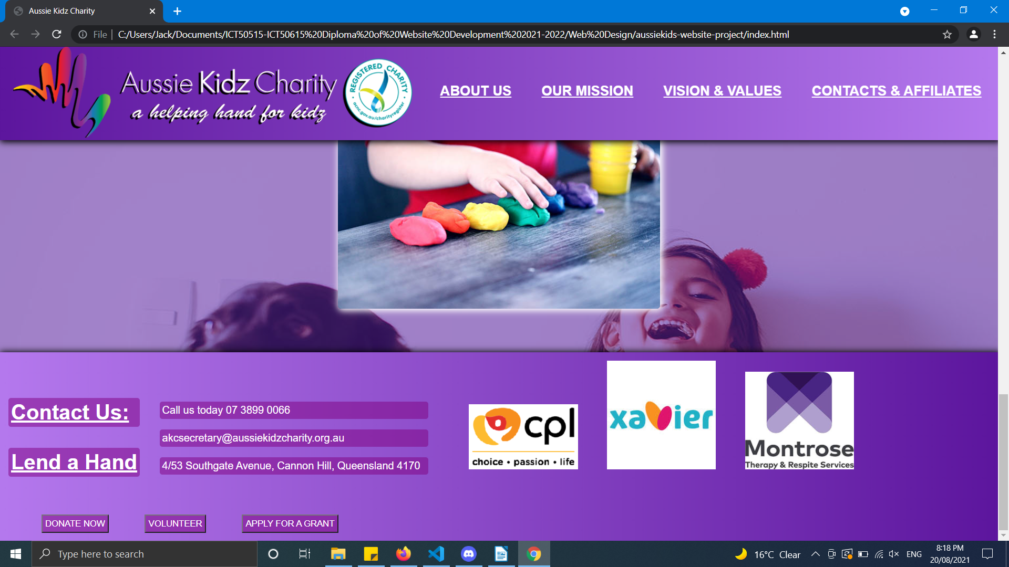~~

**Cross Browser Testing**

Mozilla Firefox

~~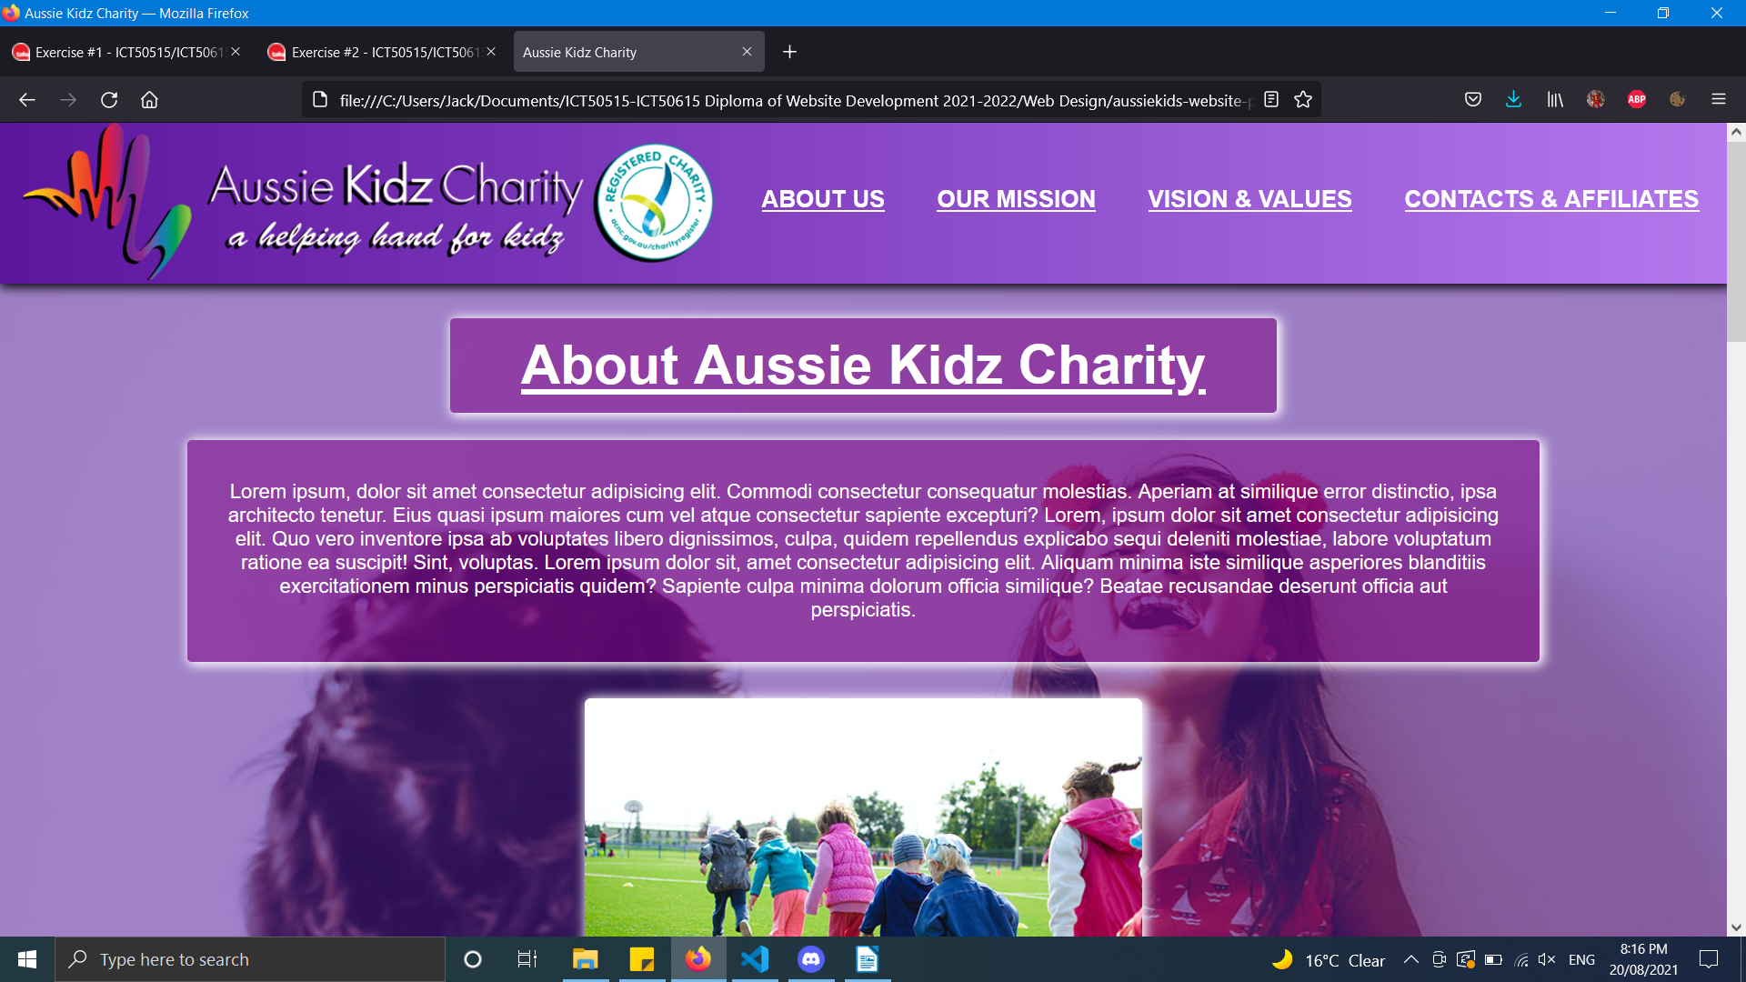~~

~~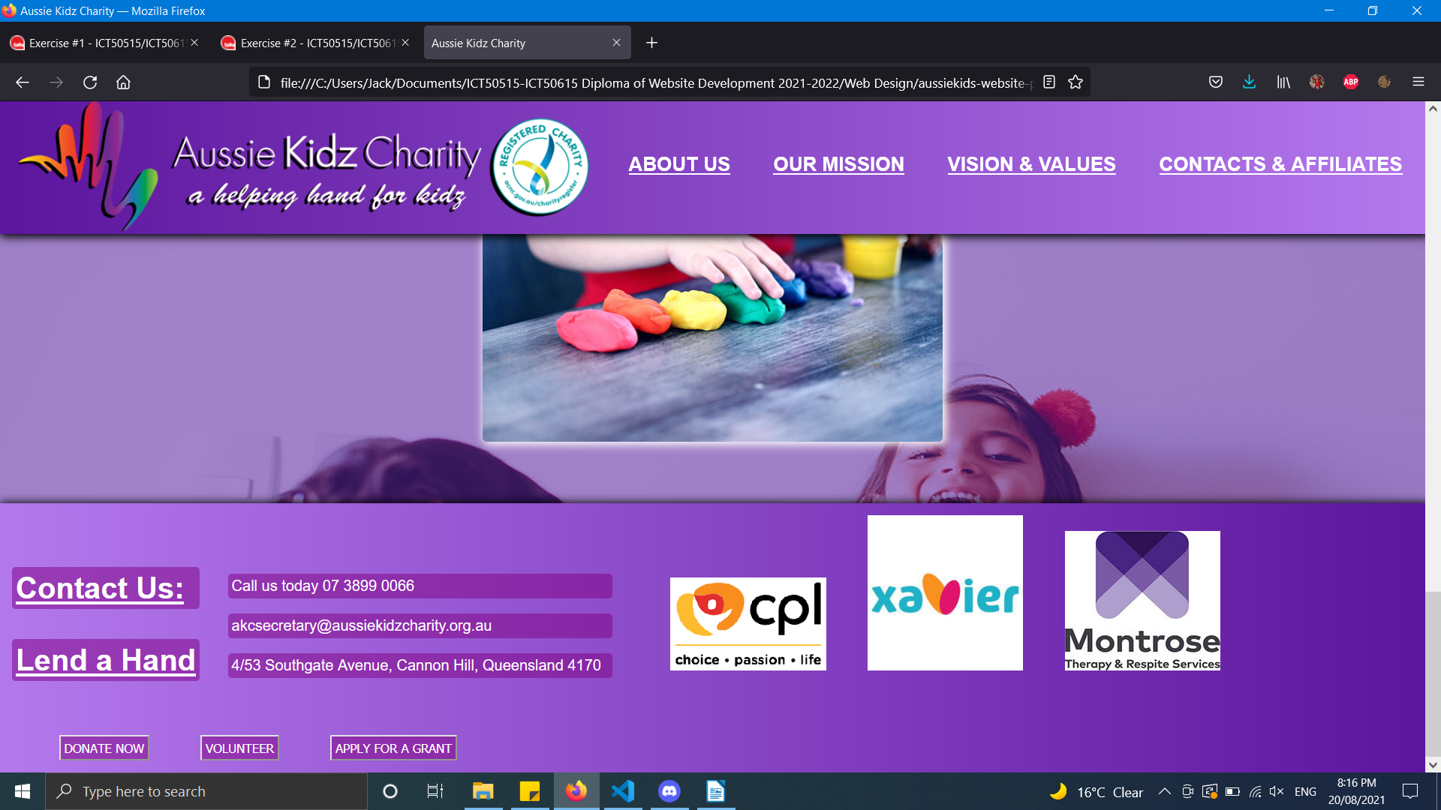~~

**Cross Browser Testing**

Internet Explorer

~~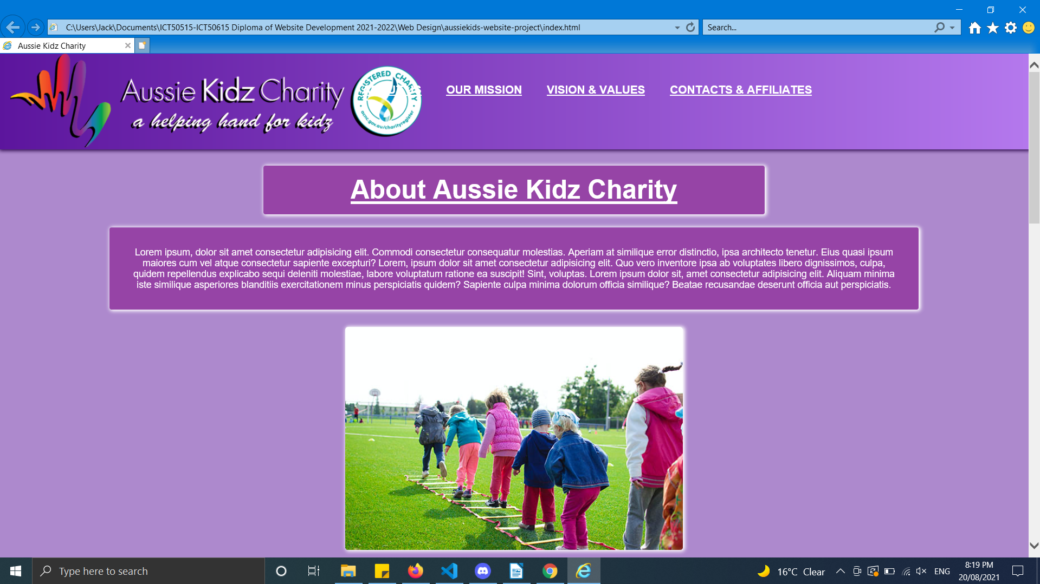~~

~~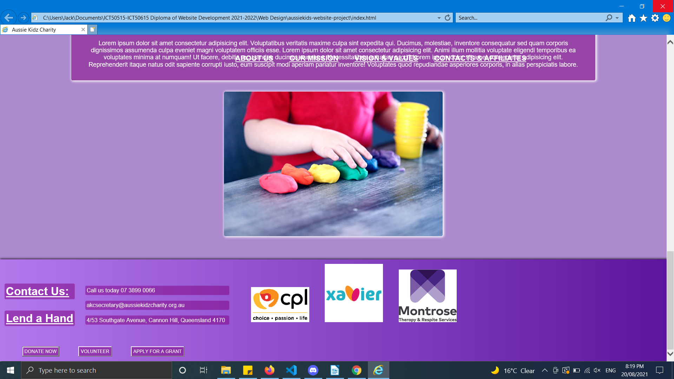~~

# **Images**

There are 5 images used on the brochure of the website. One in the header, 3 in the main and one in the footer. The only one spanning a whole element being the footer image. All images fall under Free to use, No attribution required or belong to the client and used with permission.

All images meed client requirements all fitting into the theme of the website and brochure being a children's charity for Australian children, all images include pictures of children.

All images have been modified from the originals mainly due to one reason being file and image size. Most images when downloaded were up to 2mb and due to potential performance issues had to be compressed and cropped to fit on the web page and load quickly when someone would be visiting the site.

For the header image being the charity logo I chose for that to be a PNG as apposed to a JPG for two reasons. Firstly having a transparent background which is only possible with the PNG format, secondly with it being the main display of the page and what you will always be looking at it needed to be high quality and due to the way the format is compressed it sacrifices file size for better a quality image. All other images on the page are in the JPG format to keep high performance and load times low.

**All Image Sources**

https://www.pexels.com/

https://aussiekidzcharity.org.au/about-us/

https://www.pexels.com/photo/children-s-team-building-on-green-grassland-296301/

https://www.pexels.com/photo/person-making-clay-figures-1449934/

https://www.pexels.com/photo/photograph-of-happy-children-1815257/

https://www.pexels.com/photo/a-kid-with-multicolored-hand-paint-1148998/

Pitch to Client

To whom it may concern,

Today I am here to bring you the latest design and progression in website technology and hope to convince you to use it for your Charity Brochure.

There are many reasons and advantages to use my web page over your current and competition. Firstly the bright colours give a happy and upbeat feel, are easy against they eye and really give a feel good vibe to your charity and organisation, really displaying the kind of charity you are. Secondly, displaying extremely well what kind of charity you are, what you do, your mission and values in short easy to read paragraphs accompanied by images (that are under free to use licences) that display different children in scenarios that draw people in through their bright smiles and happy nature. Thirdly, the website is light, loads quickly and is easily printable into a one page pdf with the use of advanced web technology so people that want to print a brochure or if your charity wants to hand out versions of it at events it is easily accessible.

Overall there are little to none disadvantages of choosing my web page are your advertisement both online and offline. I very much wish to hear back from you soon so we can begin negotiating.

Thank you.

Jack King

# W3C Validation

